**Genii Analytics | PDF Reports | AQA**

V1. December 2020

Contents

Agent Detail PDF Report 3

Team Leader Performance PDF Report 6

Team Leader and Agent Performance 6

Team Leader Performance 7

Team Leader, Agent and Assessment Performance 8

Campaign Productivity PDF Report 9

Assessor Hourly Report 10

Daily Comparative Report 11

Daily Campaign Assessments Distribution 12

Call Assessment Distribution PDF Report 13

Coaching Feedback Distribution PDF Report 14

Site Overview and Usage PDF report 17

General Icons

Open Filter Icon



This icon will display your filter options per report. And will therefore have different selections options depending on your campaign configurations.

Clear Filter icon



This icon will clear all existing filter selections and set all the default parameters.

The dates will default to the campaign set dates.

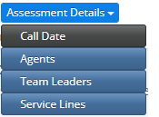

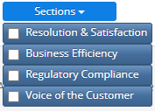

# Agent Detail PDF Report

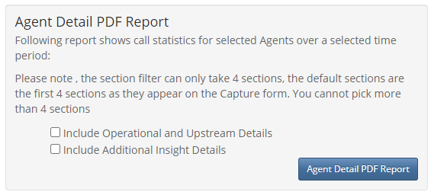

This report will give you section scores for a selected period per agent, with associated comments.

The report will display controllable failures per assessment with a Review hyperlink to Coaching Feedback.

Upstream and Added insight detail can be added to the report using the tick box buttons.

Agents are grouped by Team Leader so you may find an agent in two or more places on the report if they have moved teams within the requested period.

Associated Date Range = Call date

Coaching Status = coaching completed (Feedback Completed) vs coaching started (anything prior to Feedback Completed)

Pass Rate = 1- (Controllable Failures / Total Assessments)

Section Scores = 1- (Controllable Failures / Total Assessments)

This report has a summary and a detailed section.

The summary is per agent and will include the section scores and pass rate as well as the total assessments and total failed assessments for the selected period.

Only 4 Section scores will display,

The default will include all section in the Pass Rate score, you can view other Section scores by selecting them on the Section Filter

Summary Section:

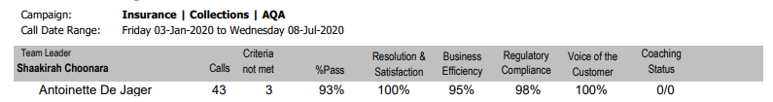

The detail of the assessments will be displayed below the summary

If a standard report (no ticks enabled) is extracted only the detail labelled *Controllable by Agent* will display.

Using the summary above this means that of the total 43 calls only 3 will display with the connection ids and failure detail as only 3 had controllable failures.

If you put a tick in the *Include Additional Insight Detail* you will get the detail for all 43 calls only because when we create a campaign we identify the Summary of Interaction Comment Box as BI or additional insights.

Therefore, by selecting this option you will get the summary comment for each connection is as well as the controllable failure comments



If you put a tick in the *Include Operational and Upstream Detail* you will connection ids where calls failed both upstream and downstream causal factors



If you select both you will get all details as per the sample below

Full Report – Detailed Section:

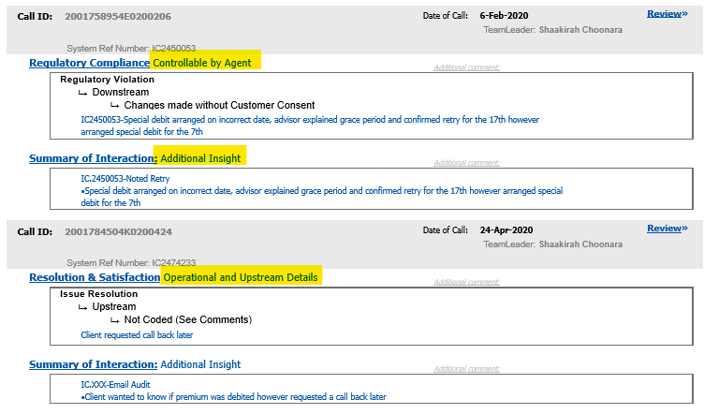

# Team Leader Performance PDF Report

## Team Leader and Agent Performance

This a summary report with 3 layers on complexity.

The default report will give you the agent and team leader summary information, including total calls, total agent failed assessments, Pass Rate and Section scores.

The default report will give summary information per team leader and agent.

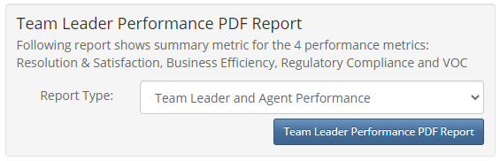

It will also include how many coaching feedbacks where completed vs how many where started.

Report View: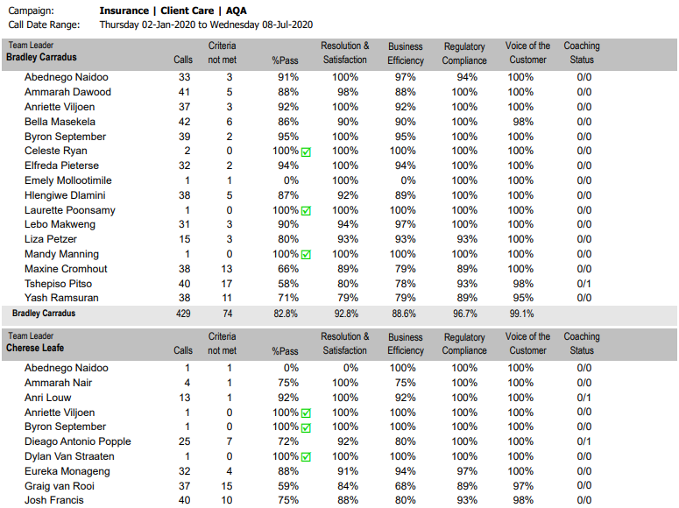

## Team Leader Performance

The next report will give the team leader summary excluding the agent information.

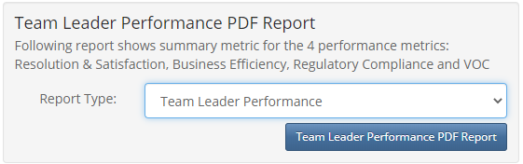

Report View:

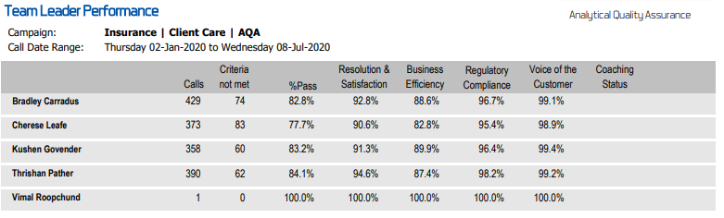

## Team Leader, Agent and Assessment Performance

The final report will include the connection id detail.

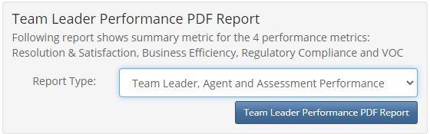

Report View:

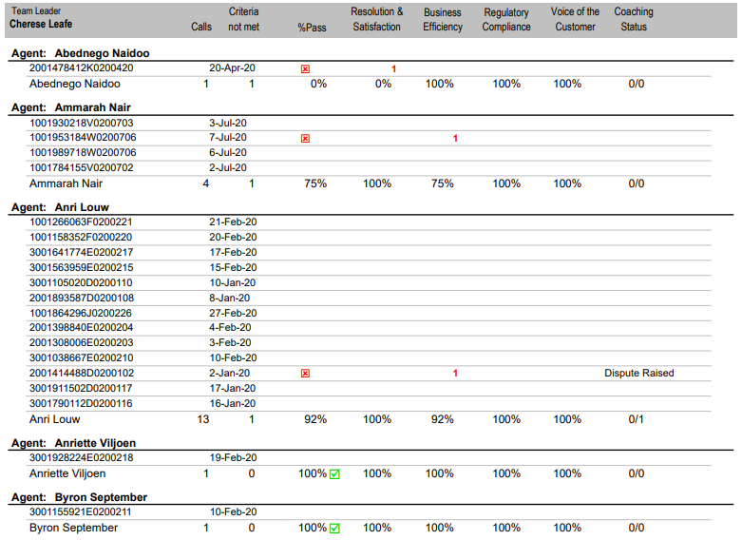

# Campaign Productivity PDF Report

This report is your assessor productivity report and would be used by the Quality manager to ensure that their QA’s are meeting targets.

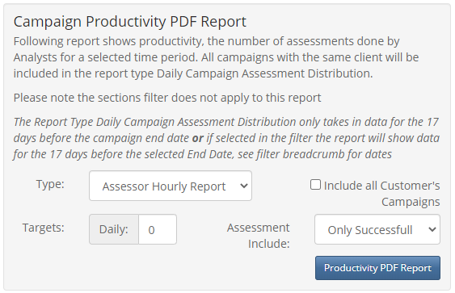

Note:

This report is dependent on captured date so make sure you have included it in your date selection. i.e. if your calls were in January but you only assessed or captured them in February you will have to include February in your date filter selection.

## Assessor Hourly Report

The default report is an hourly report.

You can set a target if you have one in your department.

By selection *Include all Customer’s Campaign*, the data will display all the assessment across the clients db.



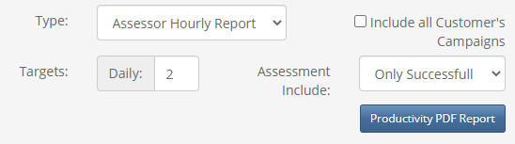

By adding a target, the resulting report will be highlighted accordingly, sample below.

The tables are displayed be assessor, per month, per day (rows), per hour (columns).

Please note legend below the table.

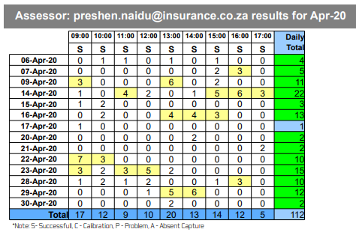

This is an assessor productivity report per campaign per month.

## Daily Comparative Report

The second report is a daily comparative report.

 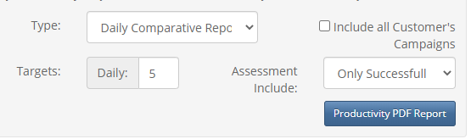

Here you can compare the productivity of the assessors per day.

Again, you can set a target, which will update the report accordingly.

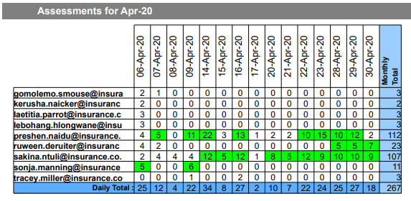

## Daily Campaign Assessments Distribution

The last report campaign comparison report with will include all the campaign on that customer without the need to select all campaign as with the previous 2 selections.

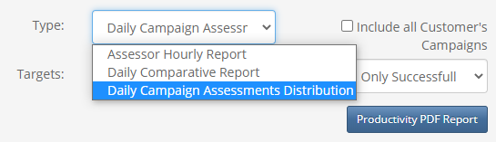

This report will only show 17 days of day from the end date you have selected on your filter.

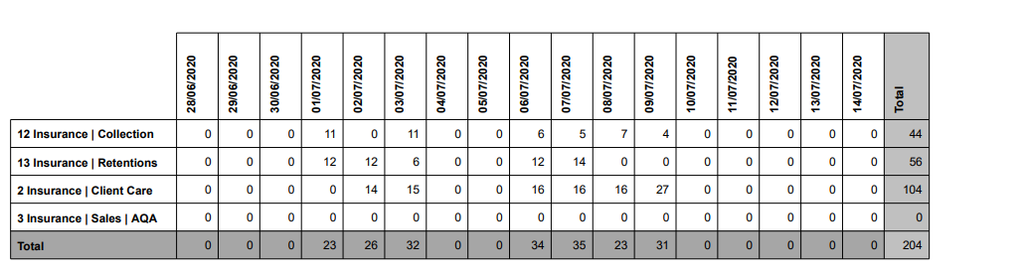

# Call Assessment Distribution PDF Report

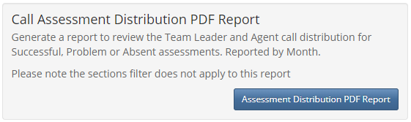

This report will display the assessment distribution counts per agent.

Grouped Month. This means and agent could appear in multiple places if they moved within the selected period.

It will show all attempt to assess the agent and categorize the calls as either Successful, Absent and Problem.

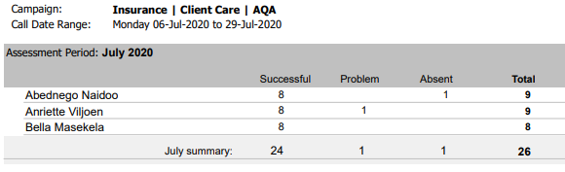

# Coaching Feedback Distribution PDF Report

This report can be used to view the productivity of the team leaders with respect to feedback.

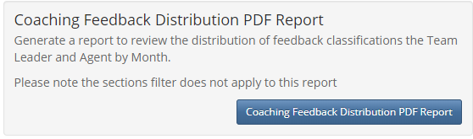

Feedback distribution per agent, per month, per team leader.

The feedback status depend on the site as clients can request addition options depending on how they want to use the app.

The numbers are per unique connection id, this means that if a feedback status has been allocated multiple times on a single connection id it will only count as one.

Example: these entries will only count as 1 as it was done on a single connection id.

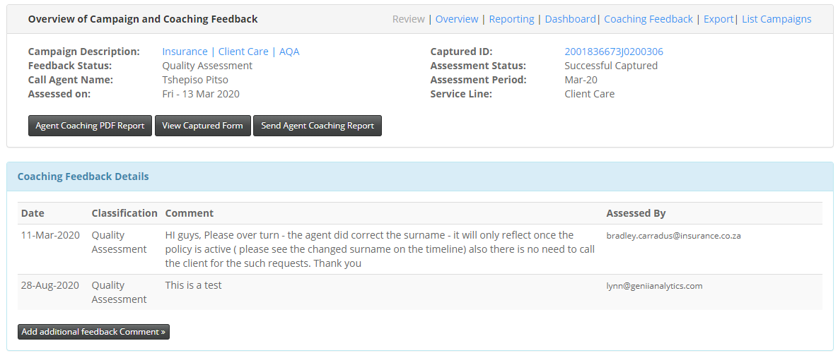

Report View

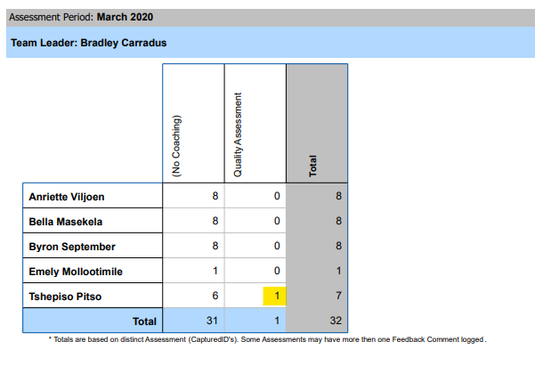

We can read the report below as follows:

Dieago had 5 assessments for January 2020.

4 assessments had no coaching done on them.

1 assessment had 2 coaching feedbacks on it Dispute Raised and Dispute Invalid.

Report View:

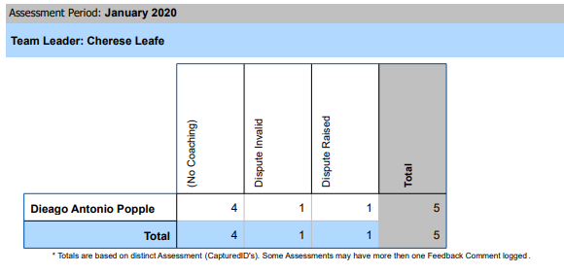

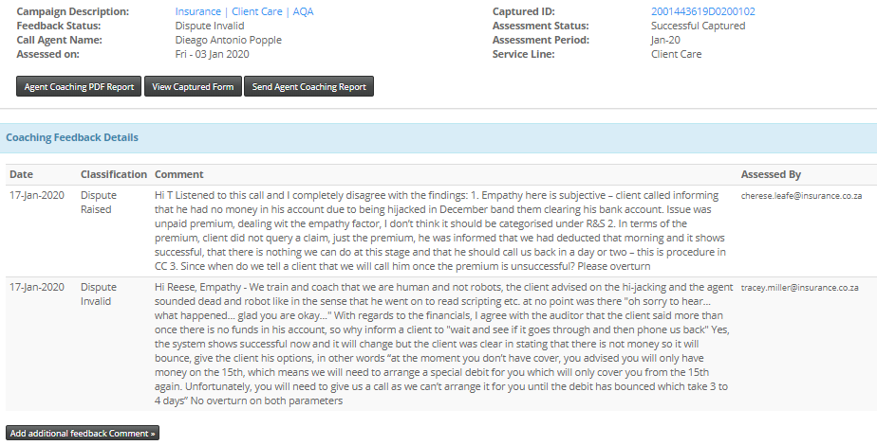

# Site Overview and Usage PDF report

Like the Campaign Productivity PDF Report this report is dependent on the capture date not the call date.

This report will also include all the campaign on this customer.

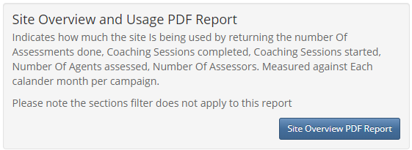

This a distribution report per campaign per month which displays counts per assessment, those being assessed, coaching and those assessing.

It should be noted that the Totals are not the accumulative of the table contents.

eg: Look at the last column in the screen shot *Unique Analysts* the total show 5 whereas the sum of the column is 9.

What this means is that there are one or more analysts capturing on multiple campaigns.

